Experiment – 15

Create a Snapshot of a VM and Test it by loading the Previous Version/Cloned VM using Vmware workstation.
AIM:
To perform snapshot creation and restoration in VMware Workstation in order to verify the ability to save and recover virtual machine states.
SOFTWARE REQUIRED:
VMware Workstation 17, Ubuntu ISO, Host OS: Windows
PROCEDURE:
1.Launch VMware Workstation 17 from the Start menu to access the virtualization environment on the Windows host system.
2.Initiate the creation of a new virtual machine by selecting the option to create a new VM and choose the “Typical (recommended)” configuration to proceed with a standard setup.
3.Select the operating system installation source by choosing the installer disc image file (ISO) option and browse to select the Ubuntu ISO file required for installation.
4.Assign a suitable name such as “Virtual Machine Ex-15” to the virtual machine and choose an appropriate storage location before proceeding with the configuration.
5.Complete the setup process by clicking Finish, after which the Ubuntu operating system installation begins automatically within the virtual machine.
6.Save the configuration settings and power on the virtual machine to ensure the guest operating system is running properly.
7.Once the system is operational, create the first snapshot by navigating to the VM menu, selecting Snapshot, and choosing “Take Snapshot,” then assign the name “Snapshot1” to capture the current state of the virtual machine.
8.After creating the initial snapshot, make changes within the virtual machine by navigating to the desktop environment and creating a new folder to modify the system state.
9.Create a second snapshot by again navigating to VM → Snapshot → Take Snapshot and assign the name “Snapshot2” to save the updated state after the changes.
10.Test the rollback functionality by selecting VM → Snapshot → Revert to Snapshot, which restores the virtual machine to the previously saved state, thereby verifying the snapshot recovery process.

IMPLEMENTATION:



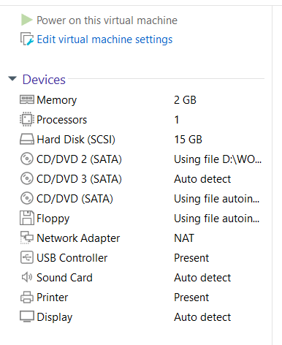

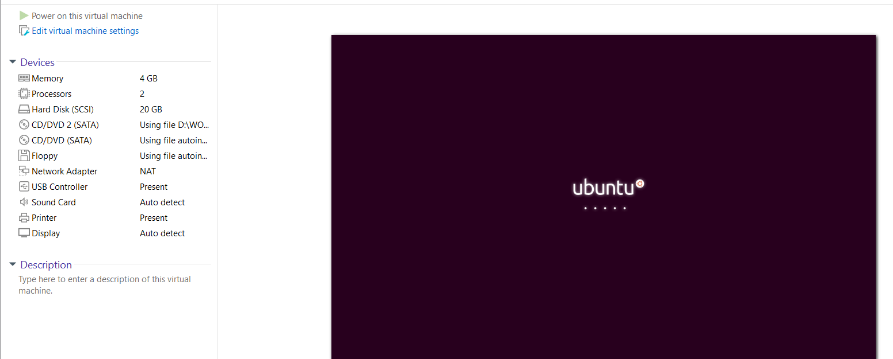

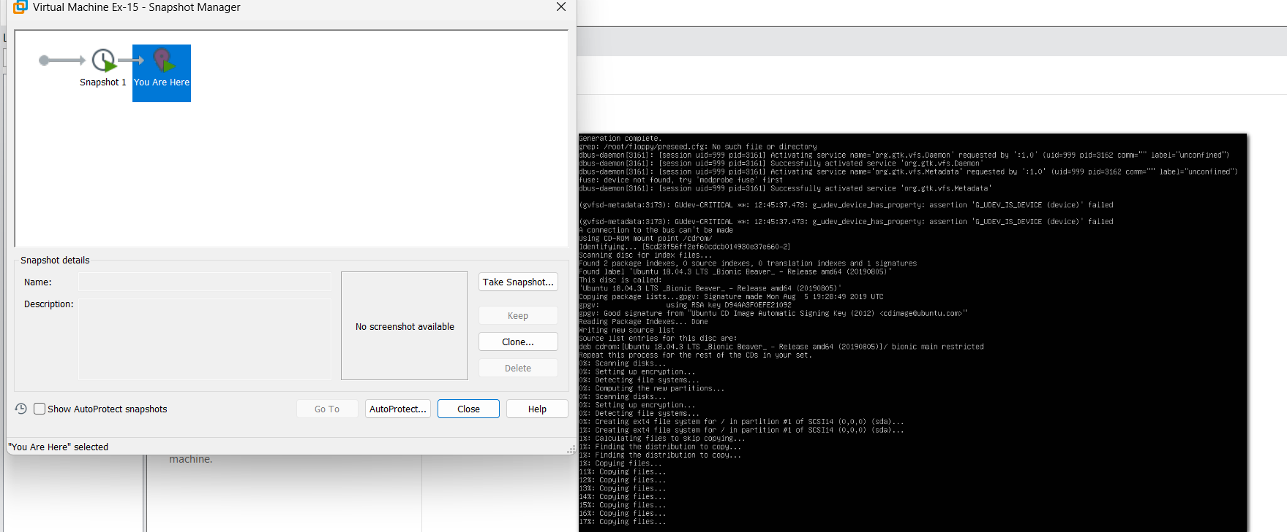

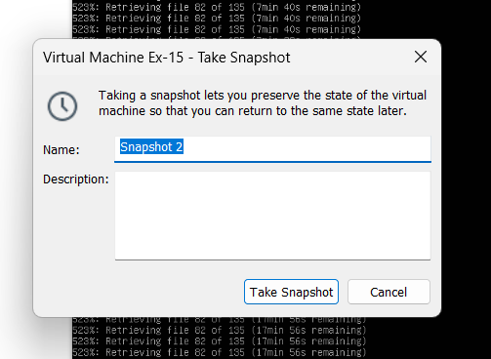

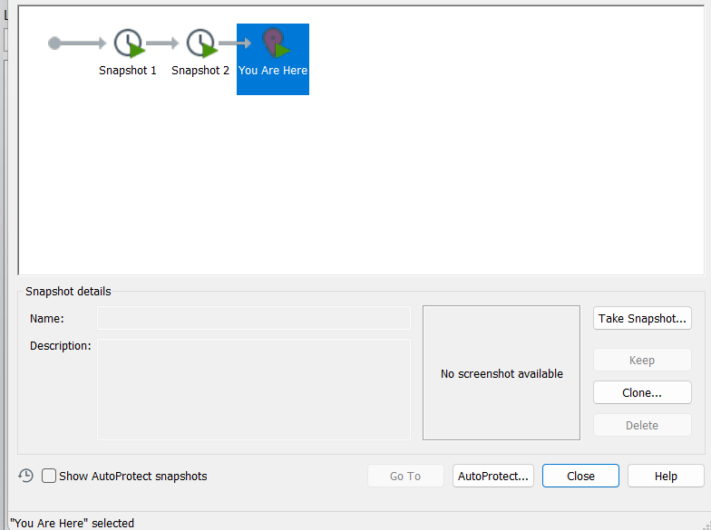

RESULT:
The snapshot functionality was successfully tested, demonstrating that the virtual machine’s state can be captured at specific points and restored accurately, ensuring effective backup and recovery within VMware Workstation.

